10.100: a)
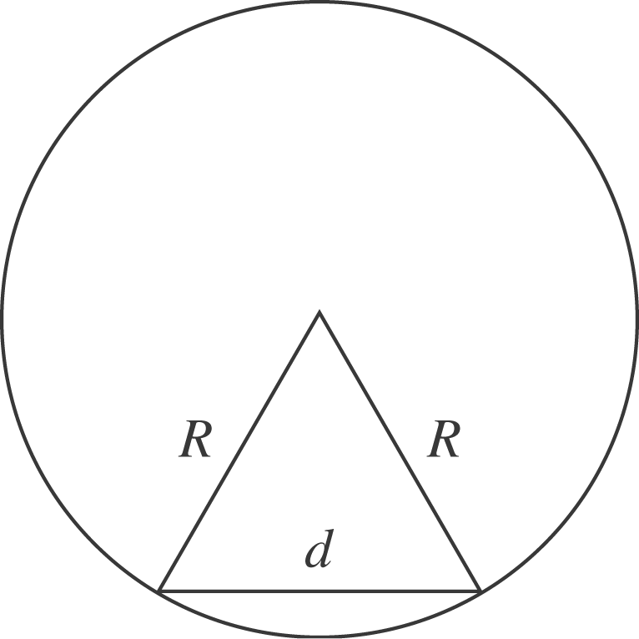

The distance from the center of the ball to the midpoint of the line joining the points where the ball is in contact with the rails is 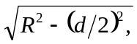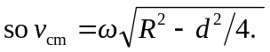
when 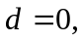 this reduces to 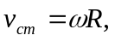 the same as rolling on a flat surface. When 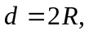the rolling radius approaches zero, and 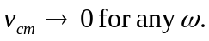

- 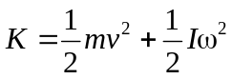
- 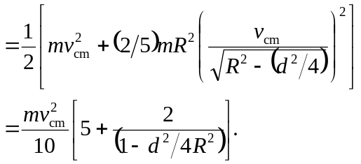
Setting this equal to 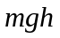and solving for 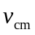gives the desired result. c) The denominator in the square root in the expression for is larger than for the case 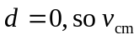 is smaller. For a given speed, 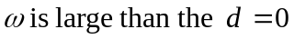 case, so a larger fraction of the kinetic energy is rotational, and the translational kinetic energy, and hence , is smaller. d) Setting the expression in part (b) equal to 0.95 of that of the 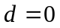 case and solving for the ratio 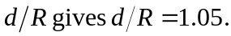 Setting the ratio equal to 0.995 gives 